# Push2Play Player Registration

**Statement of confidentiality**

This document is for the sole and exclusive use of Lotto NZ. The information contained is confidential.

Version history

| Date | Version | Change | Author |
| --- | --- | --- | --- |
| 06/04/2016 | 0.1 | Initial draft created | Johnson Mar |
| 07/04/2016 | 0.2 | Changes are based on outcome of meeting today at Lotto NZ and further discussions with Leona after the meeting. |  |
| 11/04/2016 | 0.3 | Confirm button changed to Continue.  Other changes as a result of discussions in today’s kick off meeting. |  |
| 14/04/2016 | 0.4 | Changes based on final UI Design specs sent on 13/04 and discussions with Leona today. Changes include images and changes to text are highlighted in blue. |  |
| 19/04/2016 | 1.0 | Baselined to v1.0. Content of Term & Conditions are still to be defined by Lotto NZ. |  |
| 21/04/2016 | 1.1 | Updated wireframes [where provided] and requirements for T&C’s. Changes are highlighted in blue. |  |

# Overview

This chapter describes the process for registering the user’s interest to receive notifications for the Push2Play (P2P) game. It addresses both the front end functionality and back end processes that occur when a user opts in.

The Push 2 Play (P2P) database tables and their columns are described in the P2P design document “Push2Play Detailed Design” – the latest version can be obtained from Ferdinand Contreras at Lotto NZ.

# Front End Scenarios:

# User has logged in

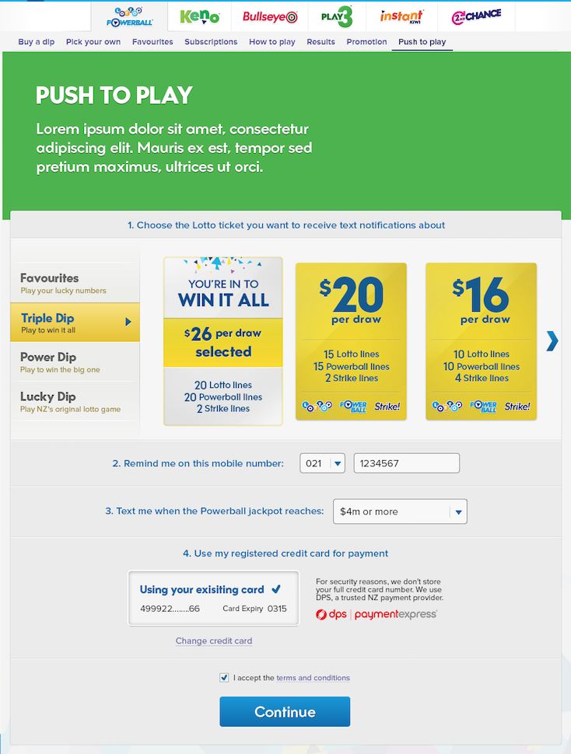

# User navigates to the Push 2 Play (P2P) landing page:

* The 3 tasks defined in this section can be performed in any order as long as it has been answered else a error message is presented to the user.

- They select from one of the following games:

* + a Favourite or a Dip,
    - * If no favourites were created prior to this opt-in process, the user can create a favourite by clicking on the Create Favourite link
* User would need to return to the P2P landing page and start the whole opt in process as no data is saved because user is navigated out of this page to create a favourite

- They enter their cell phone number which is comprised of 2 fields next to the following text label: “2. Remind me on this mobile number:”

* + The first field is a dropdown:
* 021
* 022
* 023
* 024
* 026
* 027
* 028
* 029
  + the second field is a text area
* An error message is presented if user enters an incorrect number: “Please enter a valid New Zealand mobile number.”

- The user selects a jackpot value that they would like to receive notifications next to the following text label: “3. Text me when the Powerball jackpot reaches:”

* + Jackpot values are defined in a dropdown as follows:
  + 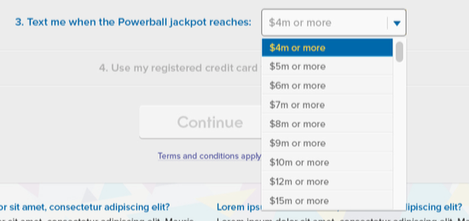

# If the user has not registered a credit card, they will be asked to Add a Credit Card else they will be presented with the credit card on record

* + When the user clicks on the Add a credit card button:

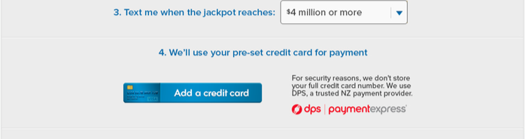

* + - User is redirected to the Top Up page where they can enter their credit card details and clicks on ‘Continue” then click on ‘Ok’. This then redirects the user back to the P2P landing page . No data loss occurs during this process [like registering a credit card for Subscriptions]
* User can amend a credit card on record by clicking on the Change Credit Card link which is only visible if one has been registered prior to this process
  + - The process that follows is the same as that for the Add a Credit Card above.
  + The Continue button is now enabled for selection
* A completeness check is performed to ensure that all of the above requirements have been met before this button is enabled

# The user then clicks on the Continue button

* + An corresponding error message will be presented to the user if:
    - * The user has not accepted the Terms and Conditions by selecting the checkbox next to the T&C’s link
* error message and display similar to that of Subscriptions
  + - * their credit card has been declined [code: -110]
      * their wallet has been suspended [code: -140]
      * their email change request is still pending [code: -160]
  + In the event that the user already has an active notification, the user will be presented with the following warning message:

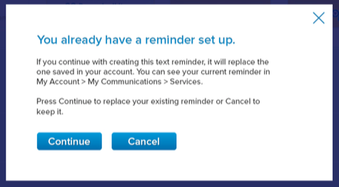

* This warning message be triggered: when the logged in user clicks on the [P2P landing page] Continue button
* When user clicks on Cancel;
* user is redirected back to the P2P landing page
* all previous data entered will not be retained
* An error message is presented to the user if the mobile number is already registered with another account
* Display the following message below the phone number fields [much like for invalid number entered]:
  + - This number is already registered. Please check that you’ve entered the correct number.
  + An error message is presented to the user if the call to Burst to send the SMS file fails:
* A record will be created in the P2P database to capture this failure
* A generic system error message will be presented to the user
  + If no errors are triggered, Mule 2.0 will generate the code and pass this to the P2P App for further processing along with the:
    - Phone number
    - [esi] User Id
    - a pop up modal prompts the user to enter the verification code

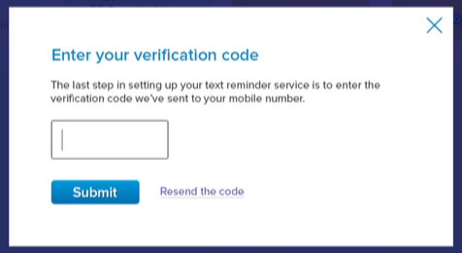

* + - A resend the code link is displayed below the code text field
    - if user clicks on “X”, user is redirected back to P2P landing page with no data loss in case user chooses [for example] to amend their selections etc

# The user will receive a Verification Code [from the P2P App] to the cell phone number they have listed above

* + The user then enters this 4 digit code into the pop up modal and clicks on Submit
* The code entered in the DFE will be verified in the UI [in accordance with chapter 9.1.2.1 of the latest P2P Detailed Design Spec].
* By matching it to the code generated defined in Step 2.3 above
  + - * If the user experiences a time out session [and is logged out] due to a delay in receiving the verification code, the user will need to restart the whole P2P notification process again
      * If the user enters the incorrect code:
* they will be presented with an error message in the modal such as “The code you have entered is invalid. Please try again.”
* there are no limits set to the number of times the user enters the code

User can click on Resend the code link to receive another Verification Code

* + If the user enters the correct code:
    - * A green tick will appear next to the the text field

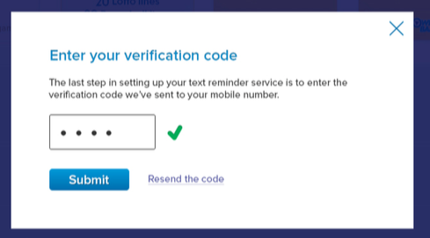

* + - * User clicks the Submit button
      * User will be presented with a success message in the modal:

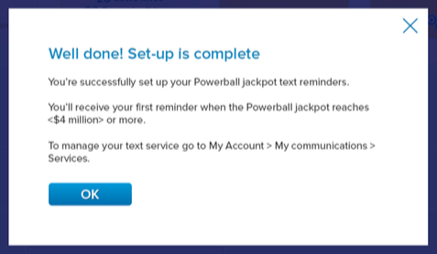

* + The message will include the jackpot value the user selected during the opt in process.
    - * Player Notifcation record is created in the P2P database. Refer to Back end process scenarios – player notification record created section below
* If the system fails to create a player notification record, user will be presented with a generic system error message [and asked to try again later?].

# The user clicks on the “Terms and conditions apply” link above the Continue button in the P2P landing page:

* + A modal pops up detailing the P2P T&C’s
    - Content for this T&C’s are managed by the CMS
  + User needs to select the checkbox before they click on the Continue button else they get an error message

# User has yet to log in:

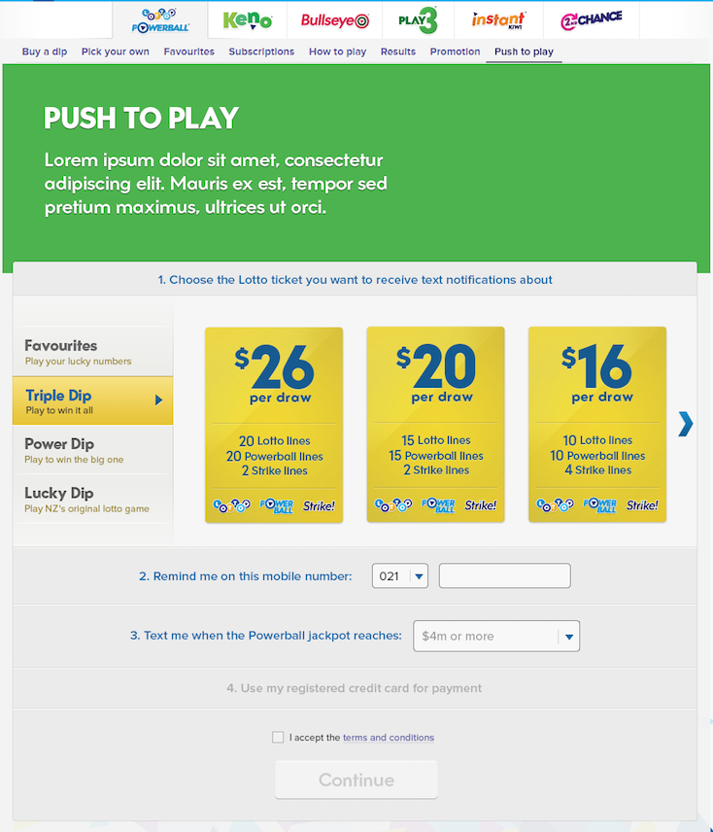

# User navigates to the Push 2 Play (P2P) landing page

* The 3 tasks defined in this section can be performed in any order as long as it has been answered else a error message is presented to the user.

- They can only select one of the published Lotto Dips:

- The user selects a jackpot value that they would like to receive notifications

* + Jackpot values are defined in a dropdown as follows:
    - $4m or more
    - $5m or more
    - $6m or more
    - $7m or more
    - $8m or more
    - $9m or more
    - $10m or more
    - $12m or more
    - $15m or more

- They enter their cell phone number which is comprised of 2 fields

* + The first field is a dropdown:
* 021
* 022
* 023
* 024
* 026
* 027
* 028
* 029
  + the second field is a text area
    - An error message is presented if user enters an incorrect number: “Please enter a valid New Zealand mobile number.”

# A system check is performed to ensure that all required questions have been satisfactorly answered. If the user has not answered all of the questions:

* + - A modal pops up [like Subscriptions] with the following error message (values are dynamic depending on what has not been answered):
* Please select the following to set up your notification:
  + Game type
  + Jackpot value
  + Cell phone number
* When the user clicks on Ok, the user is redirected back to the P2P landing page.
* Although this deviates from the wireframe, Leona has agreed to maintain functionality to that of Subscription [as defined above]

# A modal pops up requesting the user to log

* + The Dynamic Login page only pops up after the user has completed all of the requirements above
    - Existing error handling to validate login credentials is applied here
  + The user is returned to the [same] P2P landing page upon succesful log in, retaining the values the user entered prior to logging in
  + The user then proceeds as per a logged in user in Step 2 above.

# User navigates away from P2P page

# A logged in MyLotto Desktop Front End (DFE) user has started the opt-in process but navigates outside of the P2P landing page [to create a favourite, for example] before clicking on the Continue button:

* + a modal pops up requiring confirmation that the user wants to leave this page.
    - No data is saved if they choose to leave the P2P landing page

# A non-logged MyLotto Desktop Front End (DFE) user has started the opt-in process but navigates outside of the P2P landing page:

* + a modal pops up requiring confirmation that the users want to leave this page.
    - No data is saved if they choose to leave the P2P landing page

# Back End Scenarios:

# Create Player Notification

# The following scenarios refer to the Create Notification process in the P2P database after the user has submitted the correct Verification Code. It requires the following input from the DFE to the P2P Db via the P2P App:

* + Phone number
  + User id [esi]
  + Verification code
  + Dip type
  + Favourite name [if applicable]
  + Jackpot value
  + Wager amount

# Player notification record created

# The logged in user submits the verification code and receives a ‘success response’

* They will be presented with a success message in the modal:



* + The message will include the jackpot value the user selected during the opt in process.
  + A Player record is created in the P2P database. Please refer to chapter 9.1.2 of the latest Push2Play Detailed Design Spec for details of the sequence flow and data capture process.

# Player notification record not created

# The logged in user submits the correct verification code and receives a error message as a result of a failed attempt to create a record of the request.

* + This could be due to the [system] unavailability of one or any combination of the following:
    - SMS Provider
    - P2P App
    - P2P database
  + The user will be presented with a generic system error message:
* If the system fails to create a player notification record, user will be presented with a generic system error message.